**IBM ASSIGNMENT-2**

**TEAM ID : PNT2022TMID42646**

**TEAM MEMBER: DANIEL JAYASURYA E(711119106006)**

**EMAIL ID : danielsurya0108@gmail.com**

**CODE:**

Import random

i=2

while(True):

a=random.randint(15,89)

b=random.randint(15,89)

if(a>20 and b<57):

print("HIGH TEMPERATURE AND HUMIDITY OF:",a,b,"%", "ALARM IS ON")

elif(a<20 and b>57):

print("NORMAL TEMPERATURE AND HUMIDITY OF:",a,b,"%", "ALARM IS OFF")

if(i<20):

i=i+1

random

else:

break

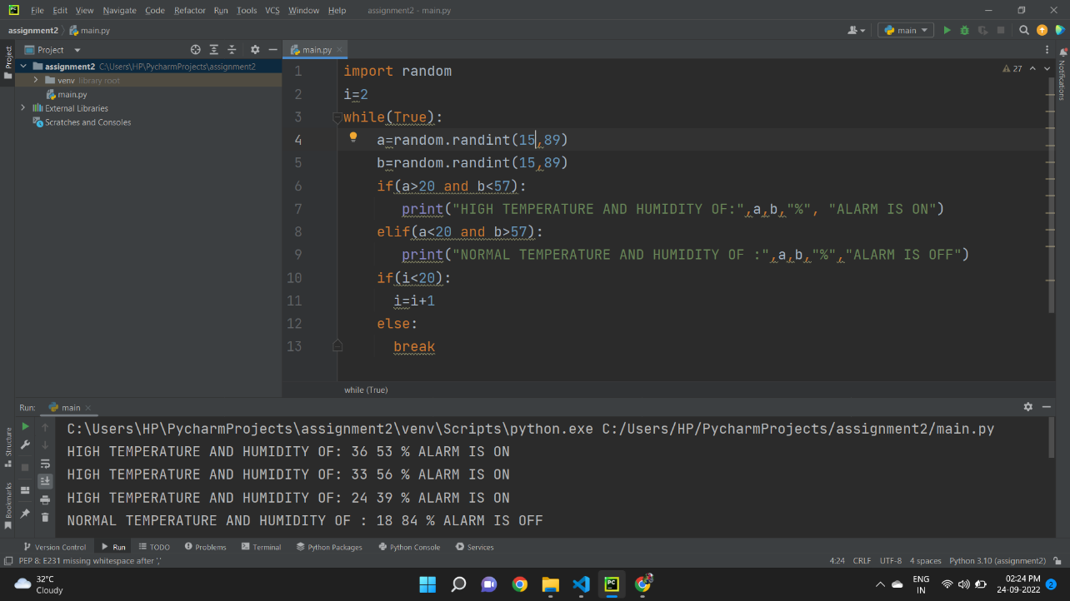

OUTPUT:

